Project Design Phase Problem – Solution Fit Template
Date | 05 August 2026
Team Id
Project Name | Automated Network Request Management in ServiceNow
Maximum Marks | 2 Marks

Problem – Solution Fit
The Problem–Solution Fit ensures that the proposed solution effectively addresses the challenges faced by users. In the Automated Network Request Management in ServiceNow project, the solution is designed to automate the complete network request lifecycle, making the process faster, more transparent, and easier to manage.

Purpose
- Solve delays and inefficiencies in the manual network request process.
- Automate request submission, approval, task assignment, and request tracking.
- Improve communication through automatic status updates and email notifications.
- Reduce manual effort and increase operational efficiency.
- Enhance user satisfaction by providing a simple and transparent request management system.
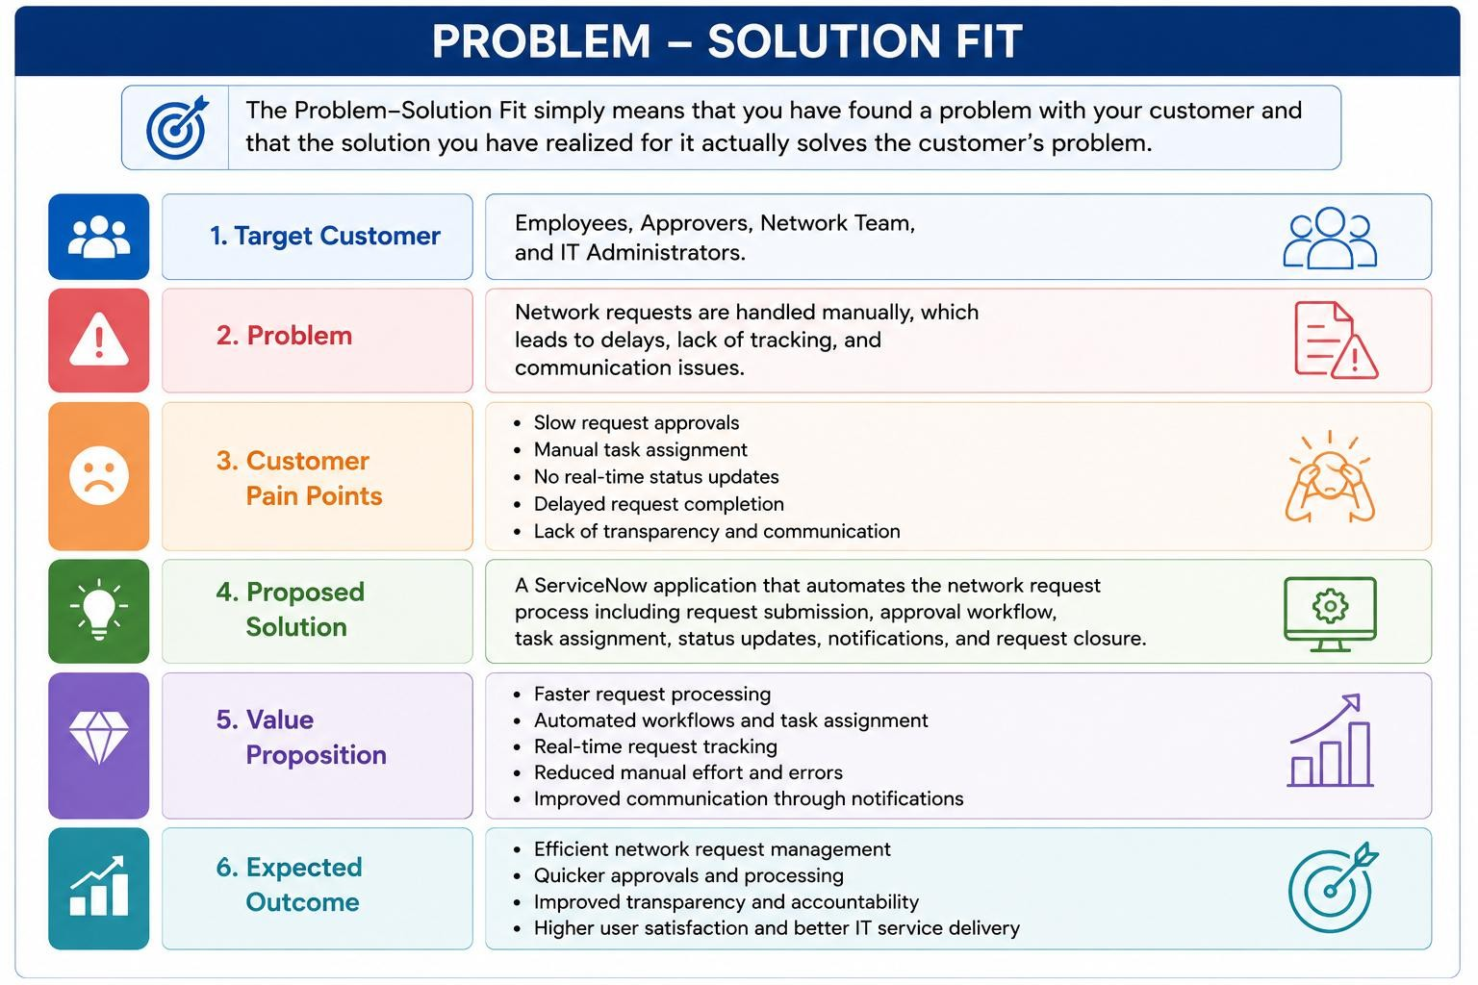
Template:

